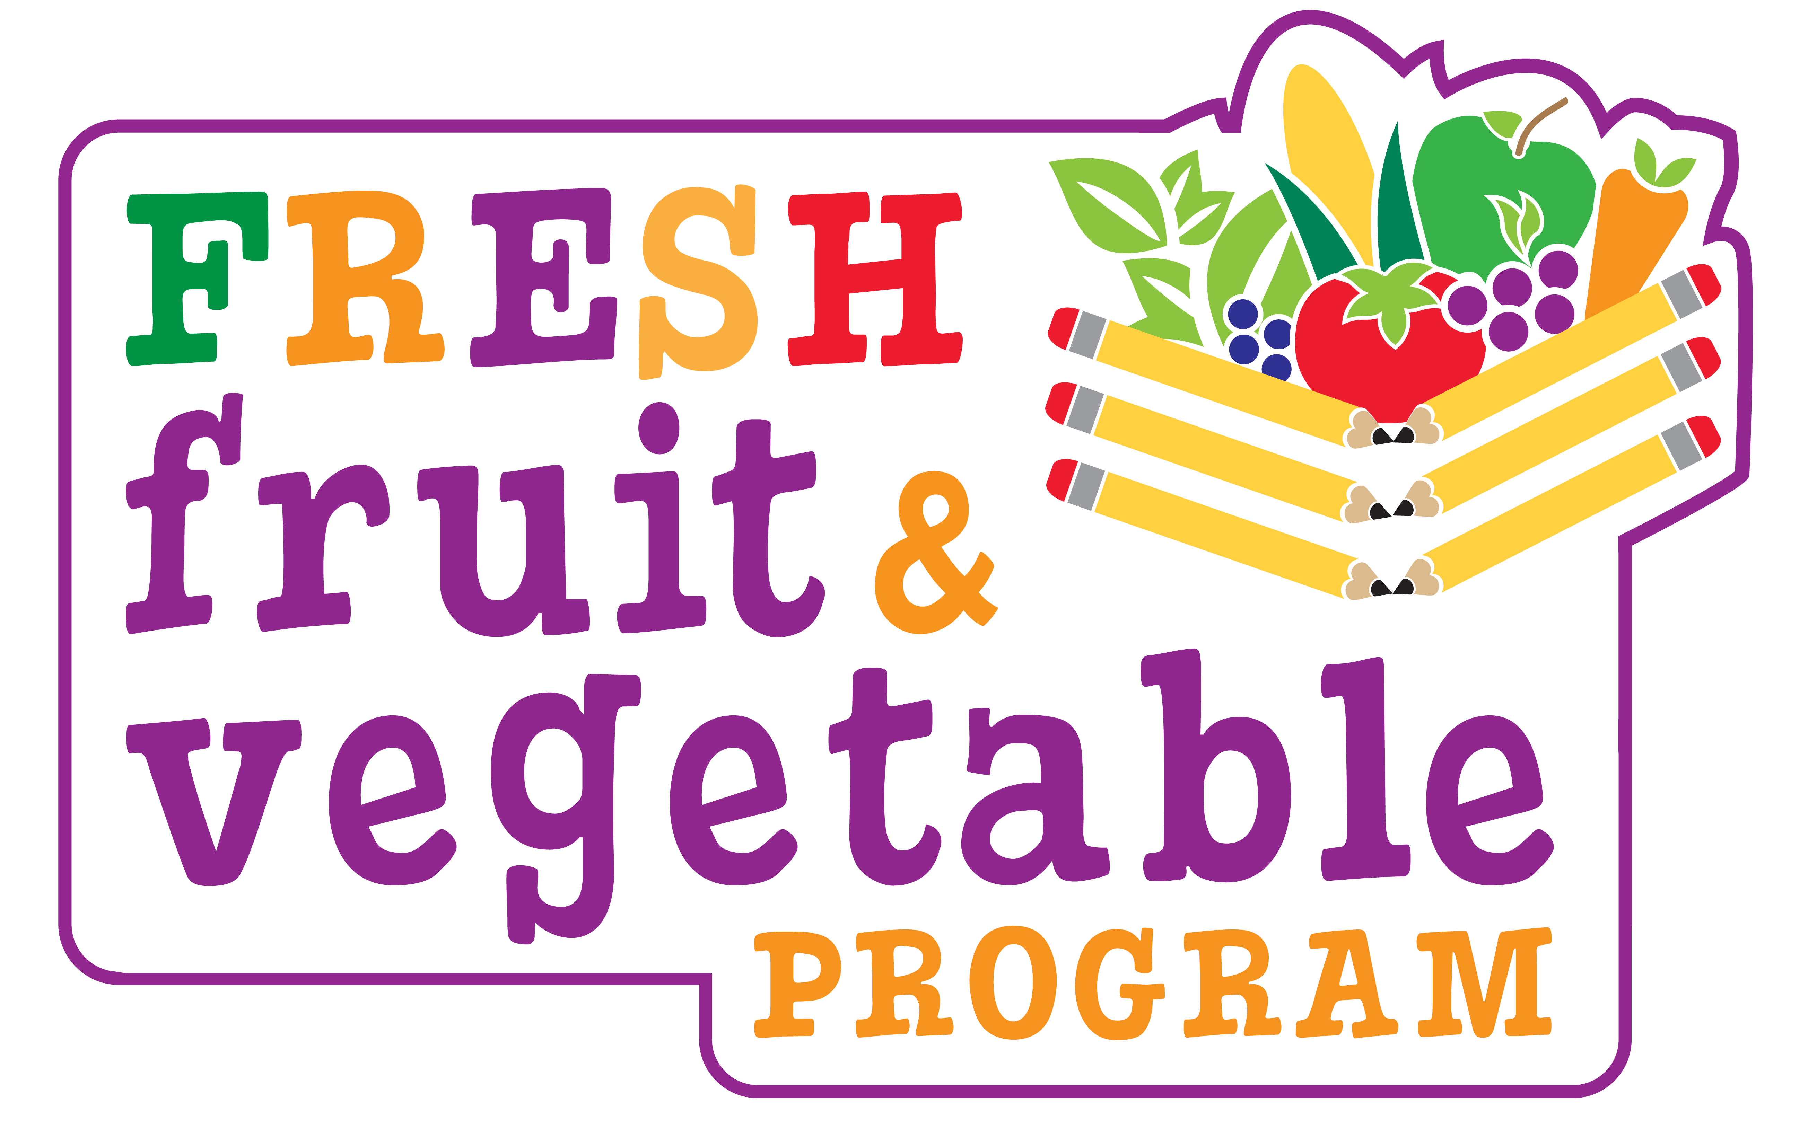

To: FFVP Principals
From: Janet Celi, FFVP Coordinator
New Jersey Department of Agriculture
Subject: FFVP “Dos & Don’ts”


Do:
- Inspire teachers to provide nutrition education such as “A to Z” Fun Facts

- Encourage Teachers to taste fruits/veggies with students

- Advocate Teachers to send home info. on FFVP snacks & recipes to try

- Allow students to eat while doing activities at their desk

- Promote classroom discussions & surveys on likes & dislikes

- Share with teachers health benefits of FFVP

- Present FFVP in a positive atmosphere at a Teachers’ meeting


Don’t:
- Allow students to take FFVP snack home

- Display negative attitudes about veggies

- Tolerate students expressing negativity about FFVP snack, especially veggies
“Don’t Yuk my Yum!”

- Consent to teachers being negative about eating raw veggies that are commonly eaten cooked

- Withhold FFVP snack for disciplinary reasons

